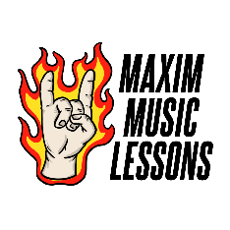

Maxim Music Lessons

What Do I Need For My First Lesson?

Here I’ve put together a list of items that are essential to your first acoustic guitar lesson with me and have also included some that I feel are optional!

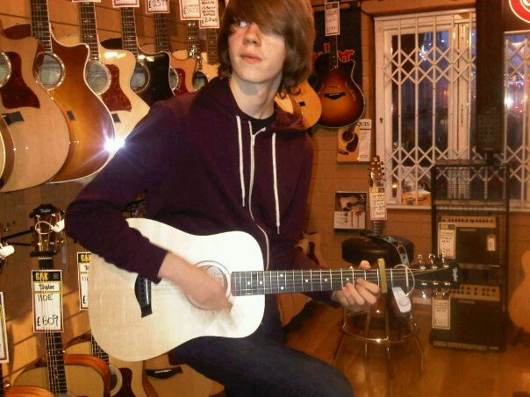Essential:

Acoustic Guitar:

What I Use: Baby Taylor BT1 Acoustic Guitar

What I Started With: Second Hand Acoustic Guitar

If you are looking to buy an acoustic guitar and you see yourself performing and spending a lot of time using your instrument, then I believe finding the right guitar for you is essential! I will always recommend going to a guitar shop and trying different brands, shapes and sizes before weighing up your options online as I feel it’s important to see how all these factors suit you in person!

On the other hand, if you have been gifted, handed down or picked up a guitar and want to have a lesson to see if you enjoy playing, then that’s also completely fine! When I wanted to start playing the acoustic, I was handed down a second-hand guitar and learnt on that until I’d saved up to buy my Baby Taylor that I still use today, 10 years later! You don’t need an expensive guitar to start learning, whatever guitar you have or choose completely depends on each individual’s needs!

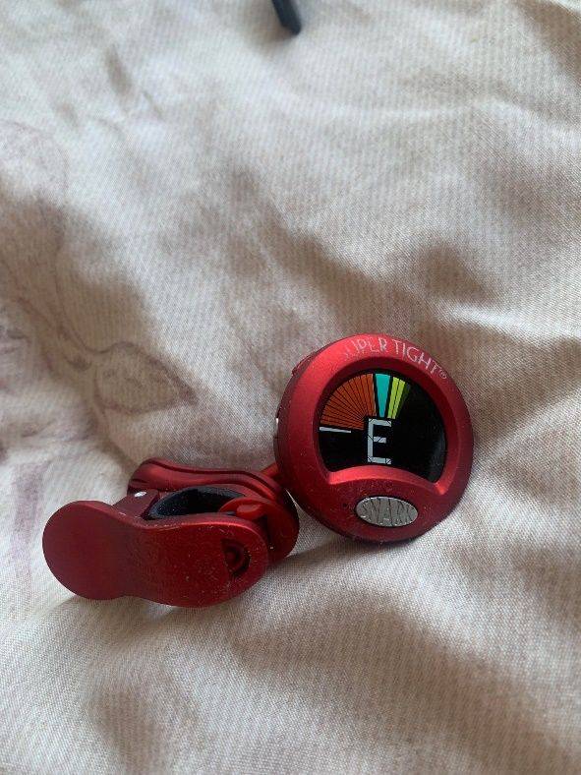A Way To Tune Your Guitar

What I Use: Snark ST-2 Super Tight Clip-On Tuner

What I Started With: Guitar Man GM11 mini clip-on tuner

Finding a way to tune your guitar that suits your needs is 100% essential! There are many different ways to tune your guitar including clip on tuners, built in tuners, pedals, tuning forks/whistles, smartphone apps and even YouTube videos! All do the same job; it just depends on what you prefer and works for your situation!

I personally prefer and have always used clip on tuners as they are accurate, portable for any situation and simple and quick to use if I’m tuning before a lesson, going on stage or just wanting to play a quick song and if that’s what you’re looking for, I’d highly recommend the Snark ST-2 Clip On Tuner as it ticks all the boxes!

On the other hand, I recommend the free “Guitar Tuner” app as part of some additional resources for students who are struggling to tune as it’s simple to use and portable as it’s on your phone! If you are reading this and this applies to you, email me at [maximmusiclessons@outlook.com](mailto:maximmusiclessons@outlook.com) once you’ve booked your lesson to sort this!



Device with webcam for use with Zoom

What I Use: Laptop

For our lessons, you will need a device that has a webcam/a function for video calls and that has the ability to install and use Zoom! This goes for most computers and smartphones but it is worth checking if your device is compatible!

I prefer and recommend using a laptop as the lesson will be more visible and it’s more efficient for using all the functions on Zoom including screen share for working on additional resources (showing chord sheets etc).

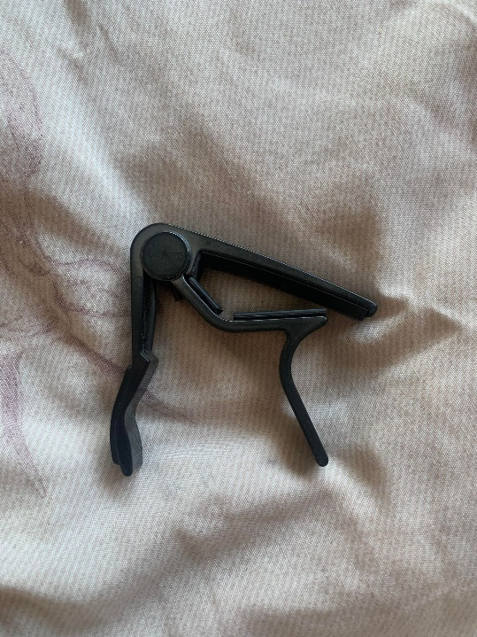Optional:

Capo:

What I Use: Dunlop 83C Acoustic Trigger Capo Curved

What I Started With: Similar Variation of Dunlop Capo

For our lessons together, I feel like owning a capo bridges the gap between essential and optional! For our first lesson, I would say optional because unless we are learning a song of your choice in the first lesson that requires a capo, it is unlikely you will need it straight away but, if you prefer to pick up everything you will need straight away, then I’d recommend picking one up! For later lessons, I’d say essential as it is very likely that we will be using a capo, using it as a songwriting tool, to explore theory and to learn a variety of songs!

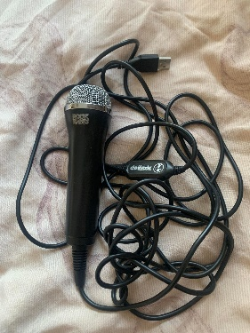There are many different types of capo but I prefer, recommend and have personally used the Dunlop Acoustic Trigger Series right from the beginning of owning a capo and wouldn’t change! They are reliable and very simple to use, perfect for any situation!

External Microphone:

What I Use: Logitech Rock Band USB Microphone

For our lessons, I’d consider picking up an external microphone! I’ve put this as optional as this is not essential, your regular microphone built into your webcam/smartphone will work just fine but having an external microphone will only enhance our lessons, providing me with clearer sound so I can really hear what I can help you with!

I personally use the Logitech Rock Band USB Microphone as it was something I already owned and it’s simple to set up and use and it’s done wonders for my lessons! If you are concerned about setting up an external microphone being too technical, going down the USB route is the most simple in my opinion!

Pen and Paper:

If you are not very digitally proficient or prefer to write and jot things down, then I recommend using a pen and paper in our lessons! I will often screen share learning materials and while some prefer to have a digital copy on their laptop or smartphone, others prefer to write it down and learn it in their own way!

Thank you for taking the time to read this and I hope it helped!

If you have any additional questions, don’t hesitate to contact me directly at [maximmusiclessons@outlook.com](mailto:maximmusiclessons@outlook.com)